Mail Crawler

Contents

1. Introduction 3

1.1. Unit Scope 3

1.2. Related Checklist 3

2. INTERFACES & ITEMs Used 4

2.1. Interfaces – 4

2.1.1. Jsoup-1.10.2.jar 4

2.1.2. org.apache.commons.io.jar 4

3. Solution Overview 5

3.1. Assumptions 5

3.2. High-Level Solution Description 5

3.3. UML Diagram 5

4. Code Changes 6

4.1. Crawler 6

4.2. IParser 6

4.3. DocumentParser 6

4.4. UriMapForYear 6

4.5. Document 6

4.6. IDownloader 6

4.7. DocumentDownloader 6

5. Testing Guidelines 7

6. Open Issues 8

# Introduction

## Unit Scope

The purpose of this document is to describe the detailed design of the **Mail Crawler**. This document will cover the following topics:-

1. Requirement for Mail Crawler, and all its related information.
2. Assumptions.
3. List of Code changes.
4. Test scenario for the whole requirement.

## Related Checklist

N/A

# INTERFACES & ITEMs Used

## Interfaces –

### Jsoup-1.10.2.jar

### org.apache.commons.io.jar

# Solution Overview

## Assumptions

NA

## High-Level Solution Description

As part of this Development, following will be done:-

A simple crawler will be designed in Java to crawl and download all mails for a particular year (say 2015) from <http://mail-archives.apache.org/mod_mbox/maven-users/>

## UML Diagram

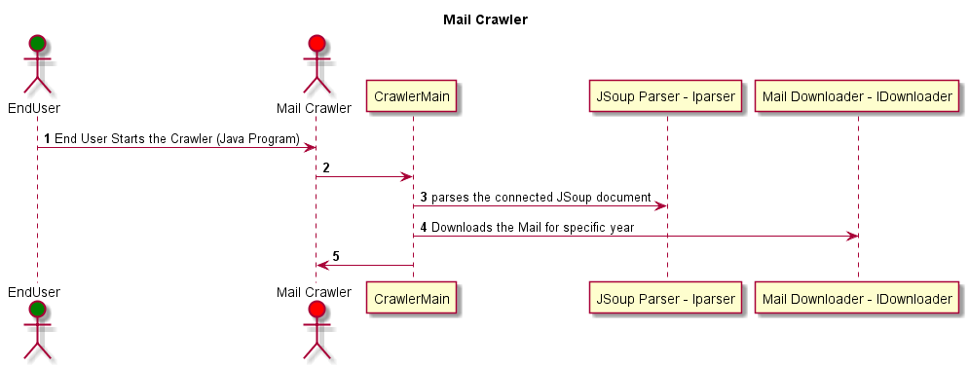

# Code Changes

## Crawler

Main class for initiating the process

## IParser

Abstract Interface for defining the parser methods

## DocumentParser

Concrete class for handling parsing mechanism of specified mail list

## UriMapForYear

Datatype that holds Map of all months with their relative URI’s

## Document

Class responsible for JSOUP library interaction for connecting to specified Mail list

## IDownloader

Abstract Interface for defining downloading methods

## DocumentDownloader

Concrete class for handling downloading mechanism of specified mail list

# Testing Guidelines

# Open Issues

Document Release Information

| Soft-ware Version | Editor | Edited Date | Comments |
| --- | --- | --- | --- |
|  |  |  |  |
|  |  |  |  |
| 1.0 | Navkaran Singh | March 19,2015 | Initial Version |